1-
CREATE TABLE:
CREATE TABLE Areas (
AreaId INT PRIMARY KEY AUTO_INCREMENT,
Name VARCHAR(100) NOT NULL,
Text VARCHAR(255),
LandScape VARCHAR(50),
Significance VARCHAR(100)
);
INSERT DATA:
INSERT INTO Areas (Name, Text, LandScape, Significance)
VALUES
('Veridian Forest', 'A dense forest with many bugs.', 'Forest', 'Early Game'),
('Mt. Moon', 'A mysterious mountain.', 'Mountain', 'Key Location'),
('Cerulean City', 'The floral city.', 'City', 'Gym Location'),
('Route 1', 'A calm path.', 'Plains', 'Starting Route'),
('Route 2', 'Path to Viridian.', 'Plains', 'Transition'),
('Pewter City', 'The stone city.', 'City', 'Gym Location'),
('Route 3', 'Rocky mountain path.', 'Mountain', 'Transition'),
('Route 4', 'Path to Cerulean.', 'Mountain', 'Transition'),
('Lavender Town', 'The noble town.', 'Town', 'Ghost Tower Location'),
('Celadon City', 'City of dreams.', 'City', 'Shopping Hub');
OUTPUT:
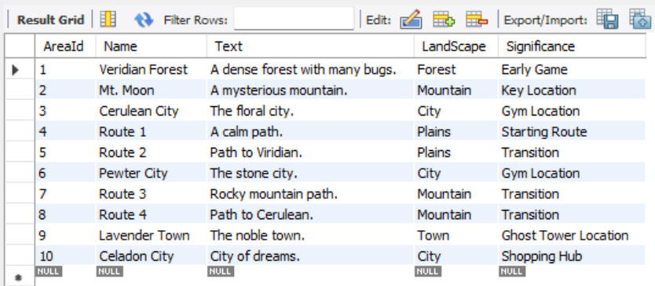

2-
CREATE TABLE:
CREATE TABLE Connectors (
ConnectorId INT PRIMARY KEY AUTO_INCREMENT,
Type VARCHAR(50),
Cost INT,
Safety INT
);
INSERT DATA:
INSERT INTO Connectors (Type, Cost, Safety)
VALUES
('Road', 0, 9), ('Cave', 0, 5), ('Bridge', 10, 8), ('Tunnel', 0, 7), ('Ferry', 50, 6),
('Path', 0, 9), ('Mountain Pass', 0, 4), ('Underground Path', 0, 8), ('Cycling Road', 0, 7), ('Surf', 0, 5);
OUTPUT:
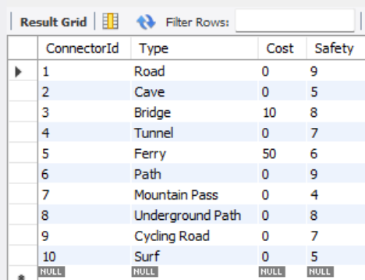

3-
CREATE TABLE:
CREATE TABLE Charms (
CharmId INT PRIMARY KEY AUTO_INCREMENT,
TimeDuration INT,
BondLevel INT,
CapturingRadiance INT
);
INSERT DATA:
INSERT INTO Charms (TimeDuration, BondLevel, CapturingRadiance)
VALUES
(100, 1, 10), (120, 2, 15), (150, 3, 20), (200, 4, 25), (60, 1, 5),
(250, 5, 30), (300, 6, 35), (180, 2, 18), (220, 3, 22), (400, 8, 50);

OUTPUT:
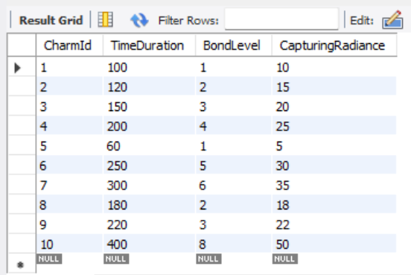

4-
CREATE TABLE:
CREATE TABLE Master (
TrainerId INT PRIMARY KEY AUTO_INCREMENT,
GiveAwayCharm INT,
Dialog VARCHAR(255),
StrongestDino INT,
DinoCount INT,
Experience INT,
FOREIGN KEY (GiveAwayCharm) REFERENCES Charms(CharmId) ON DELETE SET NULL
);
INSERT DATA:
INSERT INTO Master (GiveAwayCharm, Dialog, StrongestDino, DinoCount, Experience)
VALUES
(1, 'Honor through combat!', 1, 2, 50),
(2, 'The path of the warrior beckons!', 2, 3, 100),
(3, 'Stone-hearted and steadfast!', 15, 2, 150),
(4, 'Nature embraces the warrior!', 4, 4, 80),
(1, 'Destiny leads forward!', 7, 1, 40),
(2, 'Harness the flowing waters!', 9, 3, 110),
(3, 'The flames demand mastery!', 5, 2, 120),
(4, 'Spirits guide my hand!', 10, 3, 150),
(1, 'Swift as the lightning!', 11, 2, 90),
(2, 'Absolute strength is victory!', 12, 1, 200);
OUTPUT:
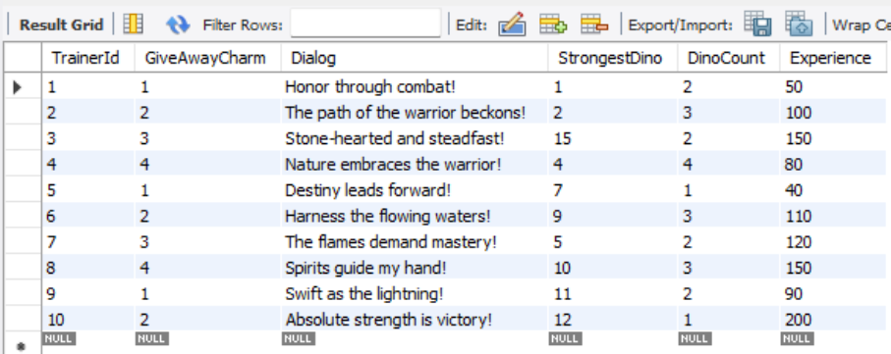
5-
CREATE TABLE:
CREATE TABLE Dino (
Dinold INT PRIMARY KEY AUTO_INCREMENT,
DinoName VARCHAR(100) NOT NULL,
DinoFamily VARCHAR(100)
);
INSERT DATA:
INSERT INTO Dino (DinoName, DinoFamily)
VALUES
('Bulbasaur', 'Grass/Poison'), ('Ivysaur', 'Grass/Poison'), ('Venusaur', 'Grass/Poison'),
('Charmander', 'Fire'), ('Charmeleon', 'Fire'), ('Charizard', 'Fire/Flying'),
('Squirtle', 'Water'), ('Wartortle', 'Water'), ('Blastoise', 'Water'),
('Pikachu', 'Electric');
OUTPUT:
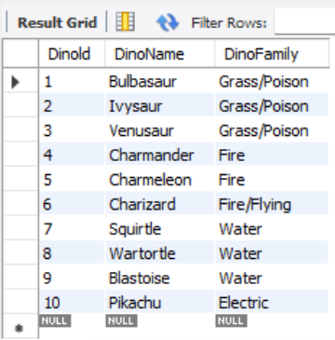

6-
CREATE TABLE:
CREATE TABLE Moves (
Moveld INT PRIMARY KEY AUTO_INCREMENT,
Discription VARCHAR(255),
Damage INT,
AddedEffects VARCHAR(255)
);
INSERT DATA:
INSERT INTO Moves (Discription, Damage, AddedEffects)
VALUES
('Tackle', 40, 'None'), ('Scratch', 40, 'None'), ('Ember', 40, 'Burn'),
('Water Gun', 40, 'None'), ('Vine Whip', 45, 'None'),
('Thunder Shock', 40, 'Paralyze'), ('Bite', 60, 'Flinch'),
('Flamethrower', 90, 'Burn'), ('Hydro Pump', 110, 'None'),
('Solar Beam', 120, 'Charge');
OUTPUT:
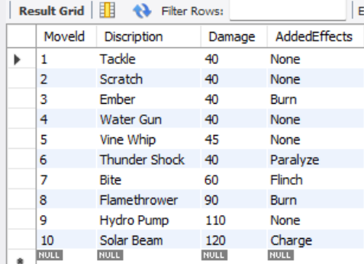
7-
CREATE TABLE:
CREATE TABLE Stats (
Dinold INT PRIMARY KEY,
Attack INT,
Defense INT,
Chant INT,
FOREIGN KEY (Dinold) REFERENCES Dino(Dinold) ON DELETE CASCADE
);
INSERT DATA:
INSERT INTO Stats (Dinold, Attack, Defense, Chant)
VALUES
(1, 49, 49, 45), (2, 62, 63, 60), (3, 82, 83, 80),
(4, 52, 43, 65), (5, 64, 58, 80), (6, 84, 78, 100),
(7, 48, 65, 43), (8, 63, 80, 58), (9, 83, 100, 78),
(10, 55, 40, 90);

OUTPUT:
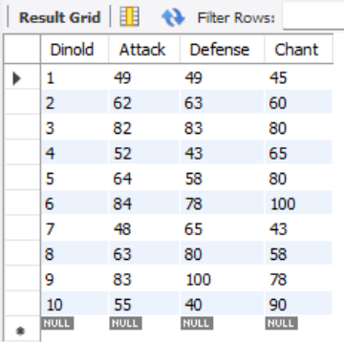
8-
CREATE TABLE:
CREATE TABLE Conditions (
conditionId INT PRIMARY KEY AUTO_INCREMENT,
Discription VARCHAR(255),
MustNotUseCharms BOOLEAN
);
INSERT DATA:
INSERT INTO Conditions (Discription, MustNotUseCharms)
VALUES
('No Items', TRUE), ('Normal Battle', FALSE),
('Weather: Rain', FALSE), ('Weather: Sun', FALSE),
('Weather: Hail', FALSE), ('No Switching', FALSE),
('Level Cap 20', FALSE), ('Level Cap 50', FALSE),
('Only Charms Allowed', FALSE), ('Only Water Types Allowed', FALSE);

OUTPUT:
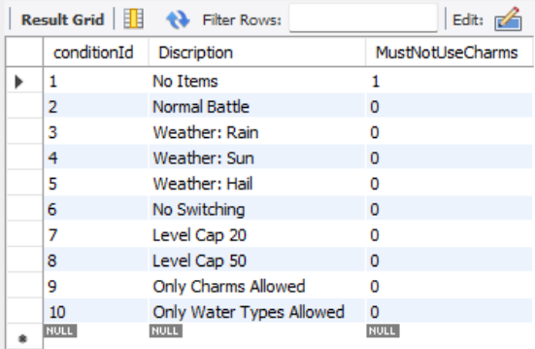

9-
CREATE TABLE:
CREATE TABLE AreasConnections (
ConnectorId INT,
Area1 INT,
Area2 INT,
Significance VARCHAR(100),
PRIMARY KEY (ConnectorId, Area1, Area2),
FOREIGN KEY (ConnectorId) REFERENCES Connectors(ConnectorId) ON DELETE CASCADE,
FOREIGN KEY (Area1) REFERENCES Areas(AreaId) ON DELETE CASCADE,
FOREIGN KEY (Area2) REFERENCES Areas(AreaId) ON DELETE CASCADE
);

INSERT DATA:
INSERT INTO AreasConnections (ConnectorId, Area1, Area2, Significance)
VALUES
(1, 1, 2, 'Main Road'), (2, 2, 3, 'Cave Path'),
(3, 3, 4, 'Bridge crossing'), (4, 4, 5, 'Tunnel way'),
(5, 5, 6, 'Water path'), (6, 6, 7, 'Mountain pass'),
(7, 7, 8, 'Steep climb'), (8, 8, 9, 'Underground'),
(9, 9, 10, 'Bike road'), (10, 10, 1, 'Surf route');
OUTPUT:
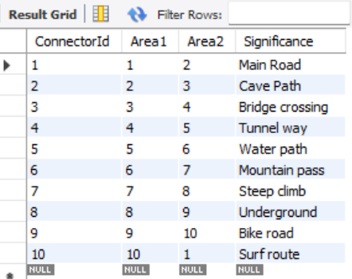

10-
CREATE TABLE:
CREATE TABLE AreaMasters (
AreaId INT,
MasterId INT,
PRIMARY KEY (AreaId, MasterId),
FOREIGN KEY (AreaId) REFERENCES Areas(AreaId) ON DELETE CASCADE,
FOREIGN KEY (MasterId) REFERENCES Master(TrainerId) ON DELETE CASCADE
);
INSERT DATA:
INSERT INTO AreaMasters (AreaId, MasterId)
VALUES
(1, 1), (2, 2), (3, 3), (4, 4), (5, 5),
(6, 6), (7, 7), (8, 8), (9, 9), (10, 10);
OUTPUT:
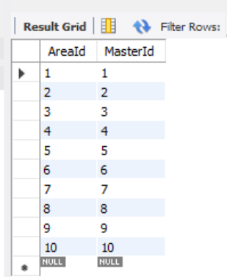

11-
CREATE TABLE:
CREATE TABLE Store (
StoreId INT PRIMARY KEY AUTO_INCREMENT,
AreaId INT,
StoreWorker VARCHAR(100),
Discription VARCHAR(255),
StoreName VARCHAR(100),
FOREIGN KEY (AreaId) REFERENCES Areas(AreaId) ON DELETE SET NULL
);
INSERT DATA:
INSERT INTO Store (AreaId, StoreWorker, Discription, StoreName)
VALUES
(1, 'Clerk A', 'Sells basic items', 'Poke Mart Viridian'),
(3, 'Clerk B', 'Sells water items', 'Poke Mart Cerulean'),
(6, 'Clerk C', 'Sells rocks', 'Poke Mart Pewter'),
(9, 'Clerk D', 'Sells incense', 'Lavender Mart'),
(10, 'Manager E', 'Sells everything', 'Celadon Department Store'),
(2, 'Hiker F', 'Sells ropes', 'Mt Moon Store'),
(4, 'Lass G', 'Sells potions', 'Route 4 Shop'),
(5, 'Bug Catcher H', 'Sells nets', 'Route 2 Stall'),
(7, 'Camper I', 'Sells tents', 'Route 3 Outpost'),
(8, 'Picnicker J', 'Sells lunch', 'Route 4 Picnic Store');

OUTPUT:
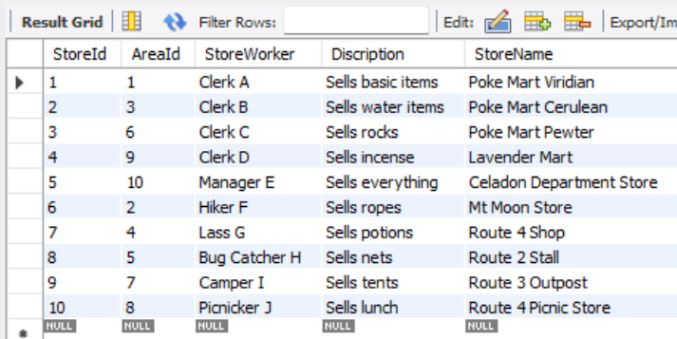

12-
CREATE TABLE:
CREATE TABLE ShopCharms (
ShopId INT,
CharmId INT,
Cost INT,
Experiece INT,
Area VARCHAR(50),
PRIMARY KEY (ShopId, CharmId),
FOREIGN KEY (ShopId) REFERENCES Store(StoreId) ON DELETE CASCADE,
FOREIGN KEY (CharmId) REFERENCES Charms(CharmId) ON DELETE CASCADE
);
INSERT DATA:
INSERT INTO ShopCharms (ShopId, CharmId, Cost, Experiece, Area)
VALUES
(1, 1, 100, 10, 'General'), (1, 2, 200, 20, 'General'),
(2, 3, 300, 30, 'Water'), (2, 4, 400, 40, 'Water'),
(3, 1, 150, 15, 'Rock'), (3, 5, 250, 25, 'Rock'),
(4, 6, 500, 50, 'Ghost'), (5, 7, 1000, 100, 'All'),
(5, 8, 800, 80, 'All'), (5, 9, 1500, 150, 'Elite');
OUTPUT:
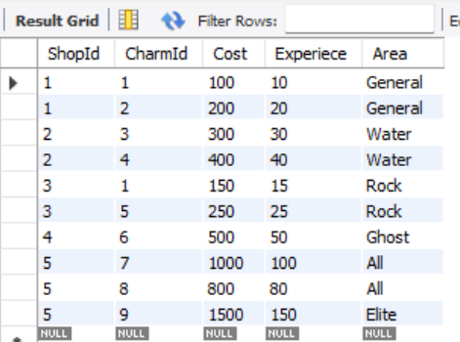
13-
CREATE TABLE:
CREATE TABLE BattleSanctum (
BattleNumber INT PRIMARY KEY AUTO_INCREMENT,
Master1 INT,
Master2 INT,
Rounds INT,
conditionId INT,
Location INT,
FOREIGN KEY (Master1) REFERENCES Master(TrainerId) ON DELETE CASCADE,
FOREIGN KEY (Master2) REFERENCES Master(TrainerId) ON DELETE CASCADE,
FOREIGN KEY (conditionId) REFERENCES Conditions(conditionId) ON DELETE SET NULL,
FOREIGN KEY (Location) REFERENCES Areas(AreaId) ON DELETE SET NULL
);
INSERT DATA:
INSERT INTO BattleSanctum (Master1, Master2, Rounds, conditionId, Location)
VALUES
(1, 2, 3, 2, 1), (3, 4, 3, 1, 2), (5, 6, 5, 2, 3),
(7, 8, 3, 3, 4), (9, 10, 5, 4, 5),
(1, 3, 3, 2, 6), (2, 4, 3, 1, 7),
(5, 7, 5, 3, 8), (6, 8, 3, 4, 9), (9, 1, 5, 2, 10);
OUTPUT:
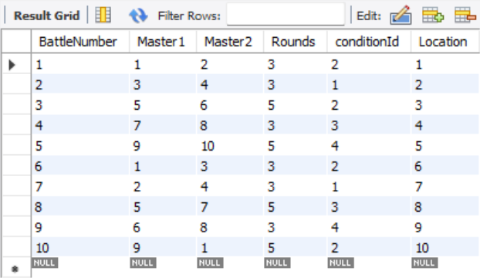
14-
CREATE TABLE:
CREATE TABLE MasterMons (
Dinold INT,
MasterId INT,
Ropeld INT,
RelicId INT,
PRIMARY KEY (Dinold, MasterId, Ropeld),
FOREIGN KEY (Dinold) REFERENCES Dino(Dinold) ON DELETE CASCADE,
FOREIGN KEY (MasterId) REFERENCES Master(TrainerId) ON DELETE CASCADE
);
INSERT DATA:
INSERT INTO MasterMons (Dinold, MasterId, Ropeld, RelicId)
VALUES
(1, 1, 1, 0), (4, 2, 2, 0), (7, 3, 3, 1),
(10, 4, 4, 1), (2, 5, 5, 0), (5, 6, 6, 2),
(8, 7, 7, 0), (3, 8, 8, 3), (6, 9, 9, 1),
(9, 10, 10, 4);
OUTPUT:
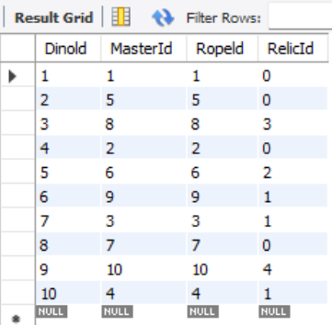
15-
CREATE TABLE:
CREATE TABLE DinoArea (
AreaId INT,
Dinold INT,
LevelObservable INT,
PRIMARY KEY (AreaId, Dinold),
FOREIGN KEY (AreaId) REFERENCES Areas(AreaId) ON DELETE CASCADE,
FOREIGN KEY (Dinold) REFERENCES Dino(Dinold) ON DELETE CASCADE
);
INSERT DATA:
INSERT INTO DinoArea (AreaId, Dinold, LevelObservable)
VALUES
(1, 1, 5), (1, 4, 5), (1, 7, 5), (1, 10, 5),
(2, 2, 16), (3, 5, 16), (4, 8, 16),
(5, 3, 32), (6, 6, 36), (7, 9, 36);

OUTPUT:
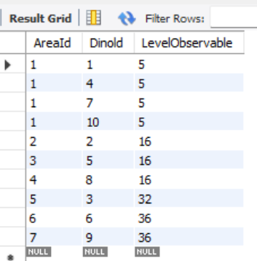
16-
CREATE TABLE:
CREATE TABLE DinoEvo (
BaseDino INT,
EvoDino INT,
RequiredLevel INT,
RequiredCharm INT,
Location INT,
PRIMARY KEY (BaseDino, EvoDino),
FOREIGN KEY (BaseDino) REFERENCES Dino(Dinold) ON DELETE CASCADE,
FOREIGN KEY (EvoDino) REFERENCES Dino(Dinold) ON DELETE CASCADE,
FOREIGN KEY (RequiredCharm) REFERENCES Charms(CharmId) ON DELETE SET NULL,
FOREIGN KEY (Location) REFERENCES Areas(AreaId) ON DELETE SET NULL
);
INSERT DATA:
INSERT INTO DinoEvo (BaseDino, EvoDino, RequiredLevel, RequiredCharm, Location)
VALUES
(1, 2, 16, NULL, NULL), (2, 3, 32, NULL, NULL),
(4, 5, 16, NULL, NULL), (5, 6, 36, NULL, NULL),
(7, 8, 16, NULL, NULL), (8, 9, 36, NULL, NULL),
(10, 10, 50, 1, 1), (1, 3, 50, 2, 2),
(4, 6, 50, 3, 3), (7, 9, 50, 4, 4);
OUTPUT:
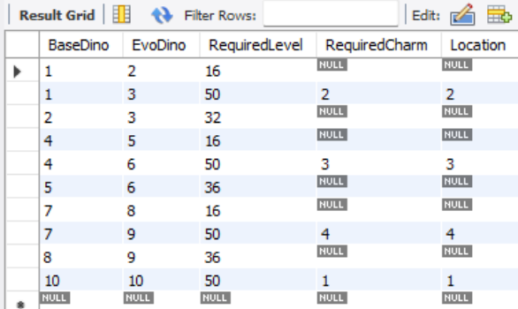
17-
CREATE TABLE:
CREATE TABLE DinoMoves (
Dinold INT,
Moveld INT,
LevelCap INT,
Area VARCHAR(50),
Charms INT,
PRIMARY KEY (Dinold, Moveld),
FOREIGN KEY (Dinold) REFERENCES Dino(Dinold) ON DELETE CASCADE,
FOREIGN KEY (Moveld) REFERENCES Moves(Moveld) ON DELETE CASCADE,
FOREIGN KEY (Charms) REFERENCES Charms(CharmId) ON DELETE SET NULL
);
INSERT DATA:
INSERT INTO DinoMoves (Dinold, Moveld, LevelCap, Area, Charms)
VALUES
(1, 1, 5, 'Any', NULL), (1, 5, 10, 'Any', NULL),
(4, 2, 5, 'Any', NULL), (4, 3, 10, 'Any', NULL),
(7, 1, 5, 'Any', NULL), (7, 4, 10, 'Any', NULL),
(10, 1, 5, 'Any', NULL), (10, 6, 10, 'Any', NULL),
(6, 8, 36, 'Any', NULL), (9, 9, 36, 'Any', NULL);
OUTPUT:
